Edwards, John

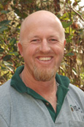

Graduated from Dwellingup cadet school in 1991. Appointed forest guard. Worked for Department of CALM. Senior Forester with Albany Plantation Forest Company 2013.

